**INCIDENT REPORT: MP-15429- Admin Log In**

**Date:11-30-2022**

**Executive summary:**

Using my OWASP Juice Shop application, log into the admin’s account without using a password from the login page.

**Results**

**Application details:**

* Application URL: https://mtpate-juice-shop.herokuapp.com/#/

**Attack Narrative:**

First I checked to see if the login page was vulnerable to SQL injections by typing a single quote in the username and I knew it was vulnerable because it returned “[object Object]” instead of the standard “Invalid email or password”. Next I entered ' or 1=1;-- in the username field and an arbitrary password (1=1 creates a true statement and -- ' is used to comment out the rest), at that point I was logged in as the admin. I also looked over the application and found the admin email address in the review of the Apple Juice.

**Conclusion:**

mtpate-juice-shop application is vulnerable to SQL injections as well as having sensitive information in plain sight.

**SQL injection**

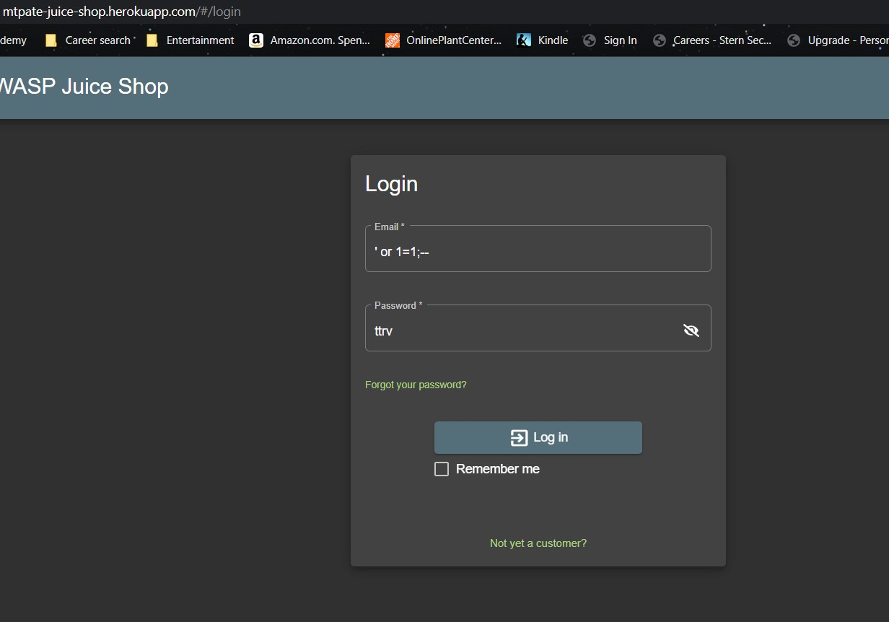

**Admin email address**

